
Course Name and Code: Data Structures Lab (ITL302)
Semester: III (SYIT)
Academic Year: 2023-24 (Odd Semester)
Name:parnika gangrade

Experiment No. 01

Aim: Implementation of any one Graph Traversal Technique for rea1-world application.

Objectives:
1. To provide the understanding of non-linear data structures and its applications in developing solutions to
real-world problems.

Theory:
Graph theory is the study of graphs, which are mathematical structures used to model pairwise relations between objects. A graph in this context is made up of vertices (also called nodes or points) which are connected by edges (also called arcs, links or lines).

Algorithm(BFS):
- Initialization: Start with a queue and a visited set.
- Enqueue the starting node and mark it as visited.
- While the queue is not empty:
  - Dequeue the front node.
  - Process the node.
  - For each unvisited adjacent node:
    - Mark it as visited.
    - Enqueue it.

Algorithm(DFS):
- Initialization: Start with a stack (or use recursion) and a visited set.
- Push the starting node onto the stack and mark it as visited.
- While the stack is not empty:
  - Pop the top node.
  - Process the node (e.g., print or store it).
  - For each unvisited adjacent node:
    - Mark it as visited.
    - Push it onto the stack.

PROGRAM:
#include <stdio.h>
#include <stdlib.h>

#define MAX_NODES 100

typedef struct Graph {
int adj[MAX_NODES][MAX_NODES];
int visited[MAX_NODES];
int numNodes;
} Graph;

void initGraph(Graph* g, int nodes) {
g->numNodes = nodes;
for (int i = 0; i < nodes; i++) {
g->visited[i] = 0;
for (int j = 0; j < nodes; j++) {
g->adj[i][j] = 0;
}
}
}

void addEdge(Graph* g, int u, int v) {
g->adj[u][v] = 1;
g->adj[v][u] = 1; // Undirected graph
}

void dfs(Graph* g, int node, int component[], int* index) {
g->visited[node] = 1;
component[(*index)++] = node;

for (int i = 0; i < g->numNodes; i++) {
if (g->adj[node][i] && !g->visited[i]) {
dfs(g, i, component, index);
}
}
}

void findConnectedComponents(Graph* g) {
for (int i = 0; i < g->numNodes; i++) {
if (!g->visited[i]) {
int component[MAX_NODES];
int index = 0;
dfs(g, i, component, &index);
printf("Connected Component: ");
for (int j = 0; j < index; j++) {
printf("%d ", component[j]);
}
printf("\n");
}
}
}

int main() {
Graph g;
initGraph(&g, 6); // Assuming 6 users (0 to 5)

// Adding edges (friendships)
addEdge(&g, 0, 1); // Alice
addEdge(&g, 1, 2); // Bob
addEdge(&g, 3, 4); // Derek
addEdge(&g, 4, 5); // Eva

printf("Connected Components in the Social Network:\n");
findConnectedComponents(&g);

return 0;
}

OUTPUT:

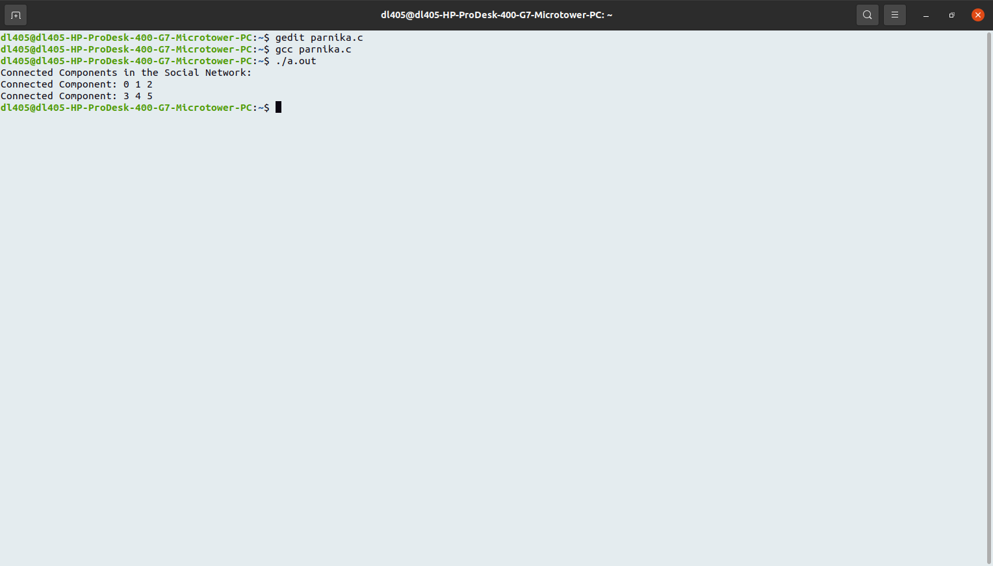

CONCLUSION:

The DFS algorithm is effective for web crawling as it efficiently traverses through web pages, capturing the structure of the site and its content. This implementation highlights how DFS can be utilized in real-world applications like web indexing. By managing visited URLs and implementing depth control, the crawler ensures a comprehensive yet efficient exploration of web content. Future enhancements could include better link normalization, handling robots.txt, and implementing breadth-first strategies for broader coverage.

